**PRACTICAL : 2**

**Aim:** Demonstrate the configuration of VLAN (Virtual LAN) using Cisco packet tracer.

**Theory:**

* **VLAN:**
* A VirtualLAN (VLAN) is any broadcast domain that is partitioned and isolated in a computer network at the data link layer.
* VLANs work by applying tags to network frames and handling these tags in networking systems – creating the appearance and functionality of network traffic that is physically on a single network but acts as if it is split between separate networks.
* The purpose of implementing a VLAN is to improve the performance of a network or apply appropriate security features.

**Topology:**

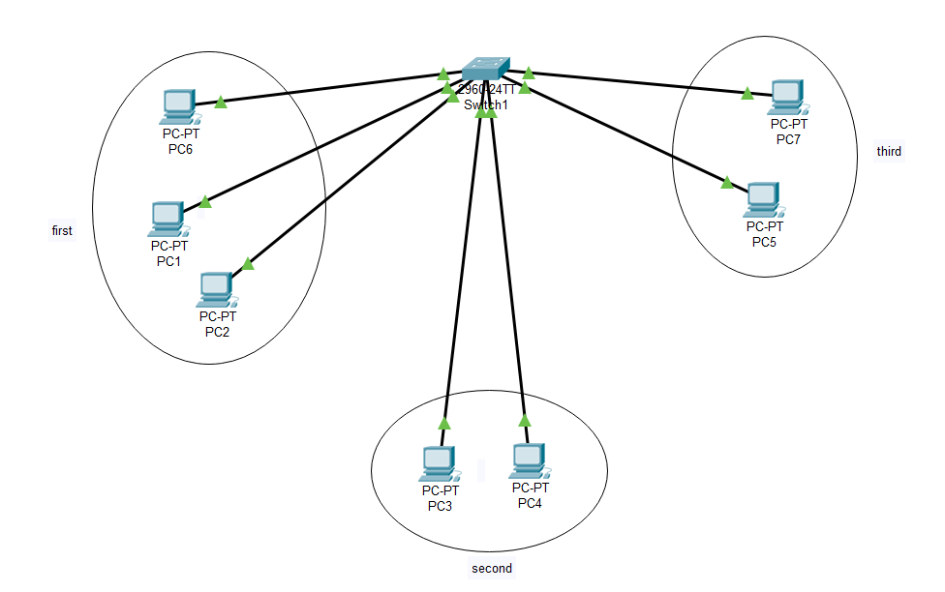

**Steps of Configuration:**

* First step is to create the topology. For that click on the device and drop on workplace and connect all the devices with the necessary cables.
* Provide the IP address to all the connected PC by clicking on the PC and selecting desktop tab in that IP configuration option.
* Next step is to configure the Switch to create Virtual LAN connection
* Click on the Switch and go to CLI tab
* To get into configuration mode, write switch > enable
* To configure the terminal, write switch # configure terminal
* To create Virtual LAN, write switch (config) # vlan 2
* To assign a name to VLAN, write switch (config-vlan) # name first
* To quit from vlan 2, write switch (config-vlan) # exit
* Follow the same steps to create 2 more VLANs i.e. second and third.
* To assign the port to VLAN, write switch (config) # interface fastEthernet 0/1
* To give access to port, write switch (config-if) # switchport access vlan 2.
* To quit from interface, write switch (config-if) #exit

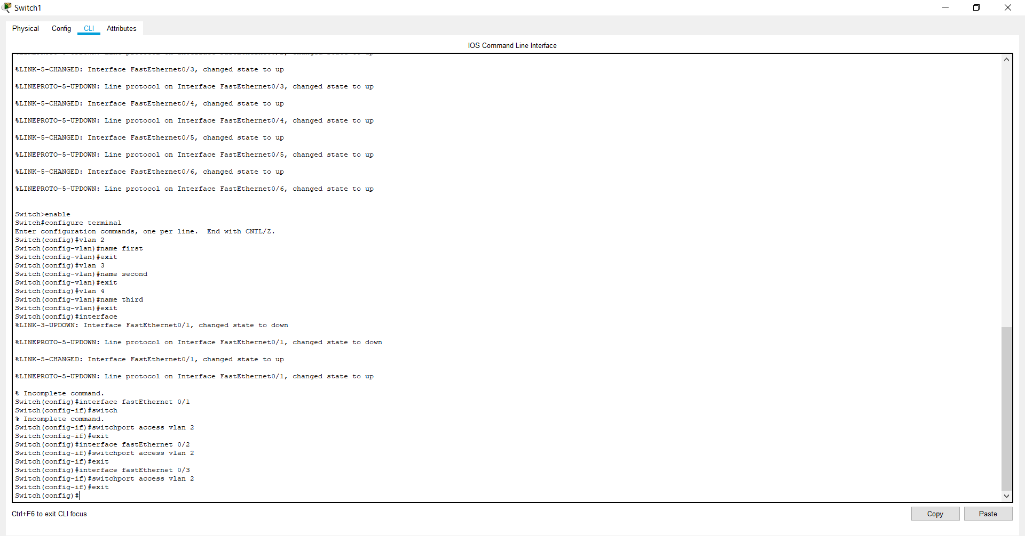

**Check Network Topology:**

* To check the topology is working or not drop on package on the one PC of VLAN 2 i.e. first and receive it from the PC of VLAN 2.
* Now drop the package on PC from VLAN 2 i.e. first and try to receive at VLAN 3 i.e. third.

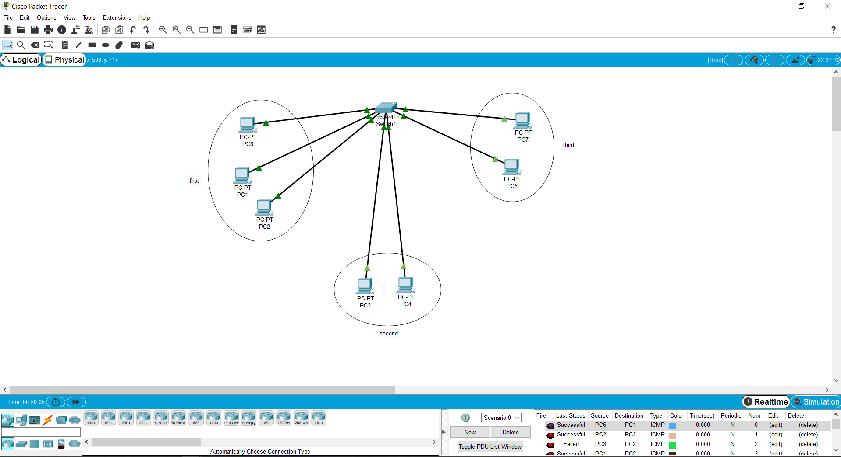

* You can also check if the connections between two PCs of same VLAN is working properly or not by following these steps;
* Click on PC of VLAN 2 i.e. first, go to Desktop tab in that Command Prompt option.
* Then simply write C: \ > ping 10.1.1.2 (// IP address of PC from same VLAN)
* Click on PC of VLAN 2 i.e. first, go to Desktop tab in that Command Prompt option.
* Then simply write C: \ > ping 10.1.1.4 (// IP address of PC from another VLAN)

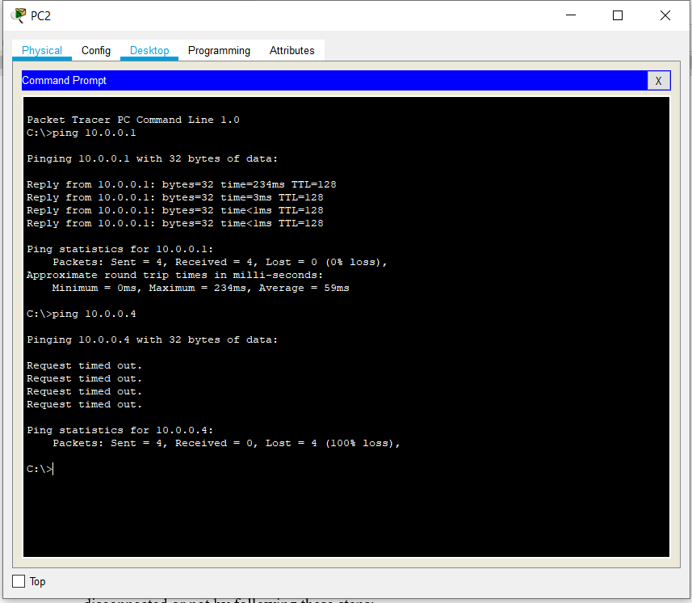

**Conclusion:**

From this practical, we are able to understand what Virtual LAN is and what is the need of VLAN. We also learn how to configure VLAN using CLI commands in Cisco Packet Tracer.